Getting Started with Istio

Setup:

Starting Minikube with extra resources for Istio:

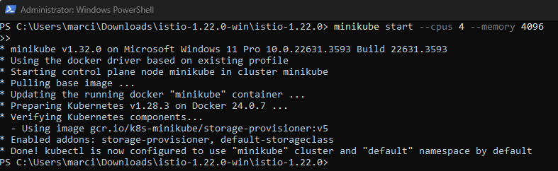

Downloading Istio

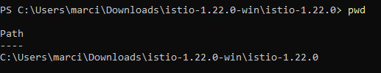

Setting up an Istio path variable



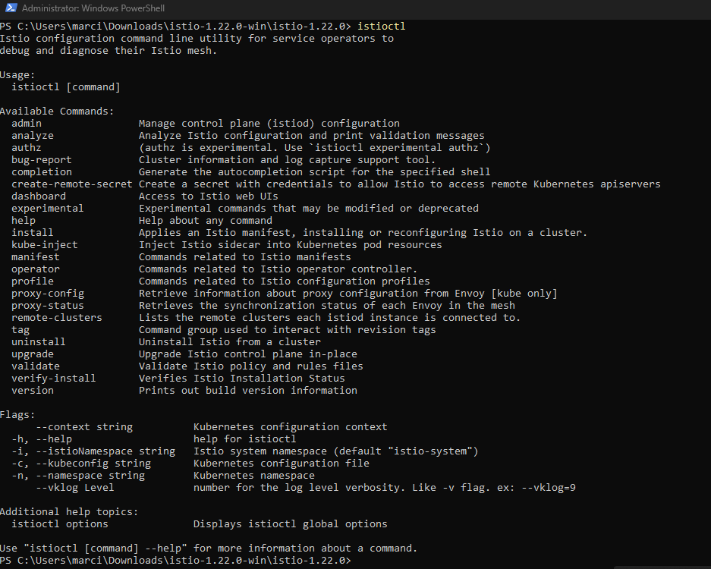

Installing Istio:

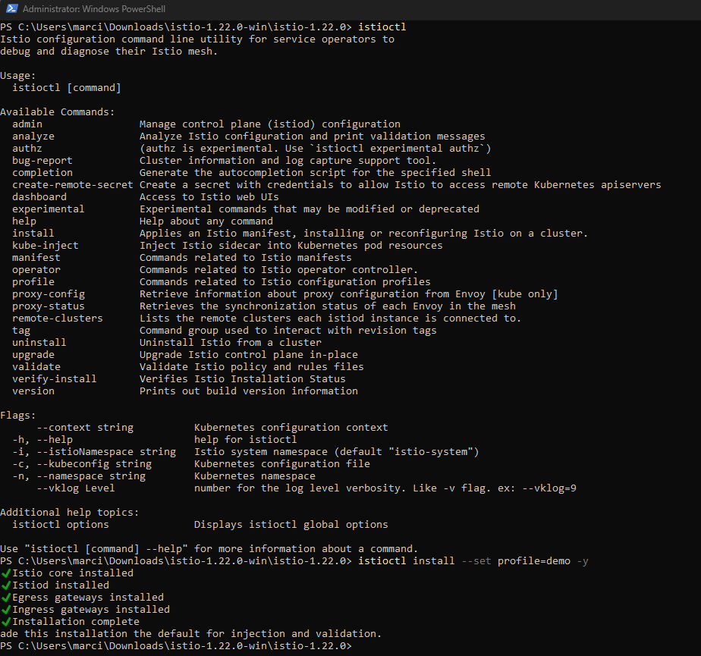

Adding a namespace label:



Deploying the Bookinfo sample application

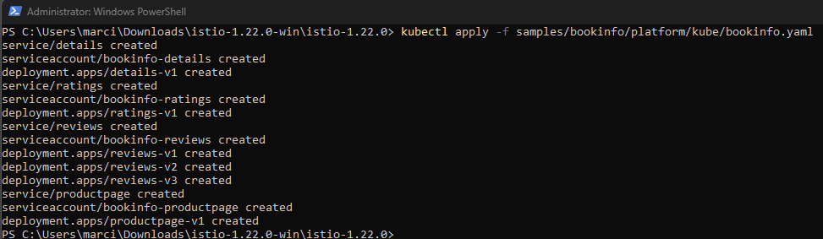

Getting the services:

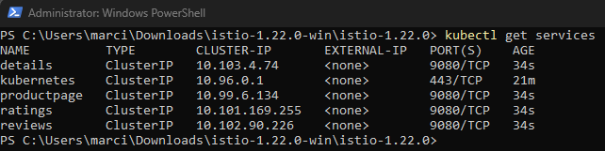

Getting the Pods:

Each pod becomes ready with an Istio sidecar deployed along with it.

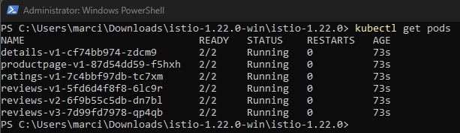

Verifying everything is working correctly by running the command below to see if the app is running inside the cluster and serving HTML pages by checking for the page title in the response:

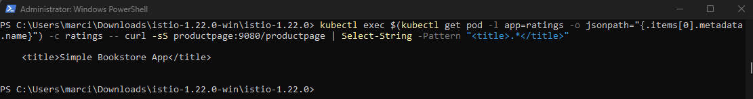

Opening the application to outside traffic:

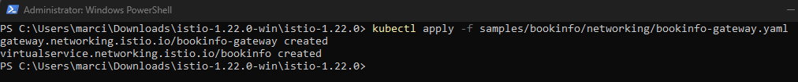

Ensuring that there are no issues with the configuration:

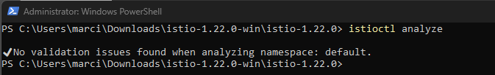

Determining the Ingress IP and ports

Stating a Minikube tunnel to send traffic to Istio Ingress Gateway:

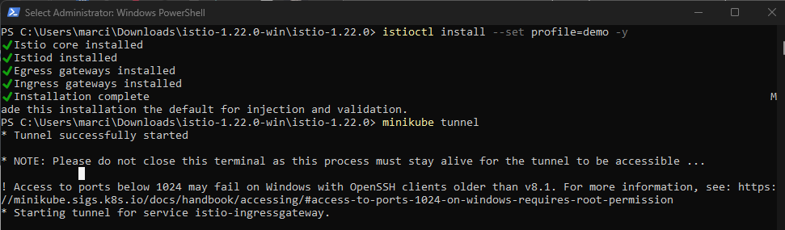

Setting up the Ingress host and ports:

Ingress Host:



Test:



Secure Ingress Port:



Test:



Setting Gateway_URL:



Fixing Gateway:



Re-Testing Gateway:





Viewing the dashboard

Deploying the Kiali dashboard:

Applying the addons

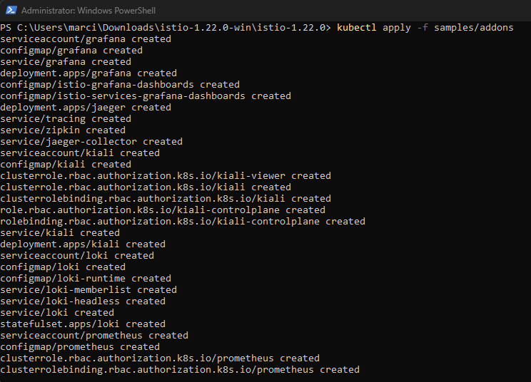

Deploying Kiali



Accessing the Kiali dashboard:

